Software Requirements

Specification

For

**Gym Management System**

**Prepared by:-**

**DHARVI KOTAK**

**SIMRAN TANTI**

**PRUTHVI THUMMAR**

**DHARM BHUT**

# RK UNIVERSITY

# Table of Contents Revision History

1. **Introduction**
   1. Purpose
   2. Document Conventions
   3. Intended Audience and Reading Suggestions
   4. Product Scope
   5. References

# Overall Description

* 1. Website Perspective
  2. Website Functions
  3. User Classes and Characteristics
  4. Operating Environment
  5. Design and Implementation Constraints
  6. User Documentation
  7. Assumptions and Dependencies

# External Interface Requirements

* 1. User Interfaces
  2. Hardware Interfaces
  3. Software Interfaces
  4. Communications Interfaces

# System Features

* 1. System Feature 1
  2. System Feature 2 (and so on)

# Other Nonfunctional Requirements

* 1. Performance Requirements
  2. Safety Requirements
  3. Security Requirements
  4. Software Quality Attributes

# Introduction

* 1. **Purpose**

Gym Management System provides the benefits of streamlined operations, enhanced administration & control. Gym Management System Service is powerful, flexible and easy to use and is designed and developed to deliver real conceivable benefits to Gym Owners.

# Document Conventions

RAM - Random Access Memory. React JS – React JavaScript.

HTML – Hyper Text Markup Language

# Intended Audience and Reading Suggestions

**Admin, Trainers and Clients:** in order to know exactly what they have to expect from the system, right inputs and outputs and response in error situations.

# Product Scope

This system is aimed to give better out look to the user interfaces and to implement all the Gyms. This project is a computer system that will be used in Gyms. The main purpose of this system is to make gym tasks easy and is to develop software that replaces the manual software system in to automated gym management system.

As a gym owner, there are numerous benefits to having the correct club management software and many options to select from. By leveraging your software to engage members smoothly, you can cut hours spent on admin, collect fees, send out invoices, automate communications, and enhance member retention. Here, we'll go future scope of gym management system goals and how to pick the best software for your fitness business.

# References

* **Websites**: Wikipedia, Google , You Tube
* <https://en.wikipedia.org/wiki/React_(JavaScript_library)#:~:text=React%20(also%20known%20as%20React,of%20individual%20developers%20and%20companies>
* <https://www.zoho.com/creator/apps/gym-management.html>
* <https://www.youtube.com/watch?v=ng-W1P8cGpk>
* <https://www.youtube.com/watch?v=Opbpj5-0Ijk>

# Overall Description

* 1. **Product Perspective**

This is totally independent system that manages activities of the gym as taking enquiries, generating customer reports, trainer management administrative issues.

In this project all the records are stored in single database. Different users have different permission to access this web application. Each user has unique id. If any data is lost user is having option to recovery. User’s don’t have right to alter records and also it is not having option to alter other customer records.

# Product Functions

The system functions can be described as follows:

* + - Registration
    - Login
    - Check Plans
    - Make Payment
    - Check Gallery
    - Contact
    - Trainer List

# User Classes and Characteristics

The system will be used in the gym. Trainer, Administrators & Customer will be the main users. Given the condition that not all the users are computer-literate some users may have to be trained on using the system. The system is also designed to be user-friendly. It uses a Graphical User Interface (GUI).

## Trainer:

Trainer has some basic computer training. They are responsible for managing customer allocated to him.

## Customer:

Customer has some basic computer knowledge. They can make enquires, view their profile details and can apply for gym membership.

## Administrators:

They all have post-secondary education relating to general business administration practices. Every administrator has basic computer training. They are responsible for all of the Adding/updating different user roles.

# Operating Environment

This proposed software will be used in Windows platform in the version of Windows 11 or above. MongoDB will be used for the database to hold the members, Trainer, and customer other details.

# Design and Implementation Constraints

The system is a web based application system running in a windows environment. The system shall be developed using React JS and MongoDB database.

# User Documentation

* + - A React Help file with a tutorial and full help on all features provided.
    - Help pages will be providing document with screen shots.
    - If the user has more queries regarding this website then he/she can contact with the administrator through contact us page.

# Assumptions and Dependencies

It is assumed that the Gym will have enough trained staff to take care of the system and have an internet connection.

# External Interface Requirements

* 1. **User Interfaces**

The user interface is designed in React JS. The developer will have to study the designing of the product. The user of the product will get very user friendly web page which will be very easy to work with.

# Hardware Interfaces

This system doesn’t require any hardware interface. The one used here is monitor, keyboard and mouse.

# Software Interfaces

* + - Operating System: Windows 7+
    - Front End: React JS, HTML, CSS.
    - Back End: MongoDB

# Communications Interfaces

Communication is done through internet and intranet mail or Telephones and Messaging.

# System Features

* 1. **System Feature 1**

The features that are available to the Admin are:

* + - Admin can Add / Delete / Update Trainers and Customer details.
    - Admin has all rights to view the details of Gym.
    - Admin can also view Transaction Details and update gym membership packages.

# System Feature 2

The features that are available to the Clients are:

* + - Can view profile history and details.
    - Makes enquiries and can take Gym Membership.
    - Can view Gym details.

# System Feature 3

The features that are available to the Trainer are:

* + - Trainer can view Member details allocated to them by Admin.
    - Mark the member attendance.

# Other Nonfunctional Requirements

* 1. **Performance Requirements**

The system manages facilities required by the casual users quickly and easily. It offers to take enquiries faster through online. It takes the enquiry details from customer and sends the feedback to the particular customer.

# Safety Requirements

* + - In case the clients forgets or loses Password, the repair functionality helps by choosing “forgot password” option in the main login window.
    - To avoid any data loss backups can be taken.
    - While typing the password, if the caps lock is on it must be notified.

# Security Requirements

This system is provided with authentication without which no user can pass. So only the legitimate users are allowed to use the application. If the legitimate user’s share the authentication information then the system is open to outsiders.

# Software Quality Attributes

**Reliability:** Good validations of user inputs will be done to avoid incorrect storage of records.

**Maintainability:** During the maintenance stage, SRS document can be referred for any validations.

**Portability:** This system can be easily viewed in any browser.

**Flexibility:** The system keeps on updating the data according to the transactions that takes place.

**Timeless:** The system carries out all the operations with consumption of very less time. **Security**: Security of the system is maintained d by giving access to only authenticated user id and password.

Diagram:

Level 0

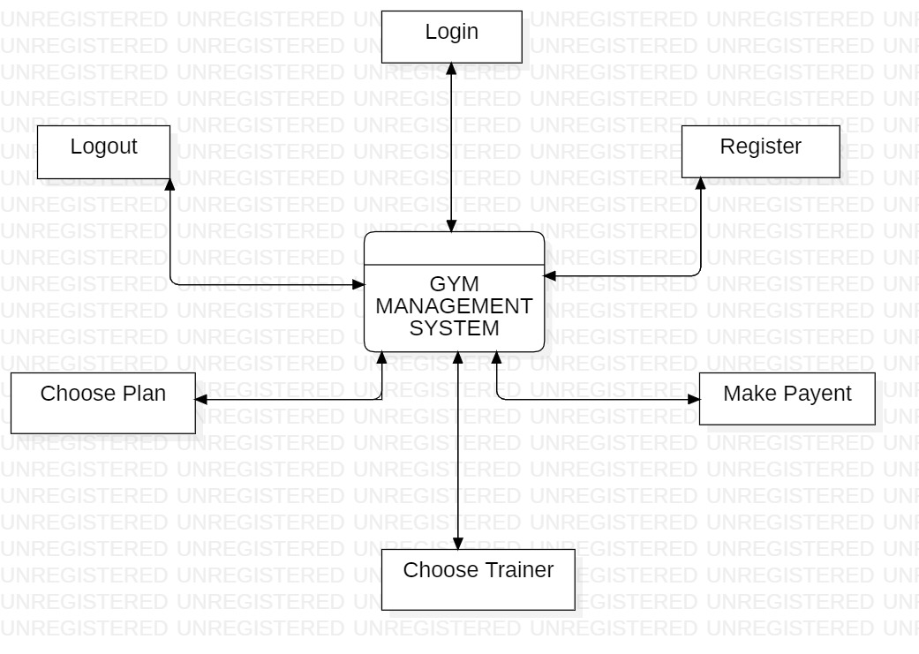

Level 1:

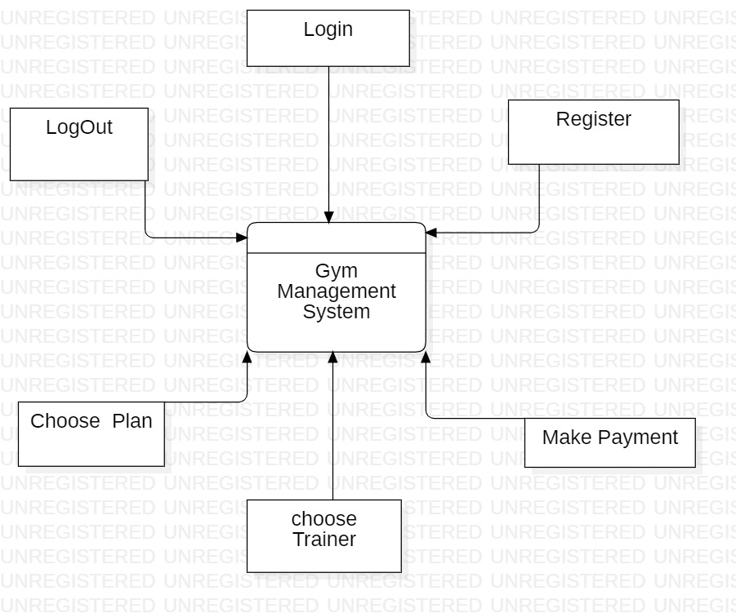

Level 2 :

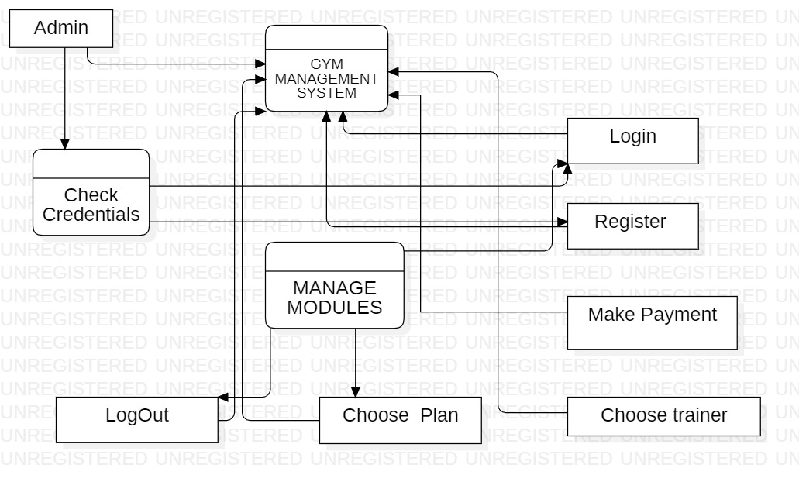

Activity Diagram :

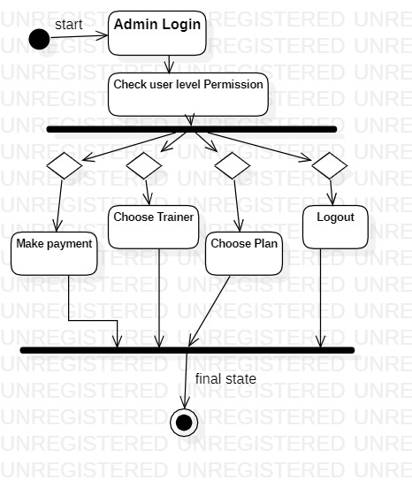

ER diagram :

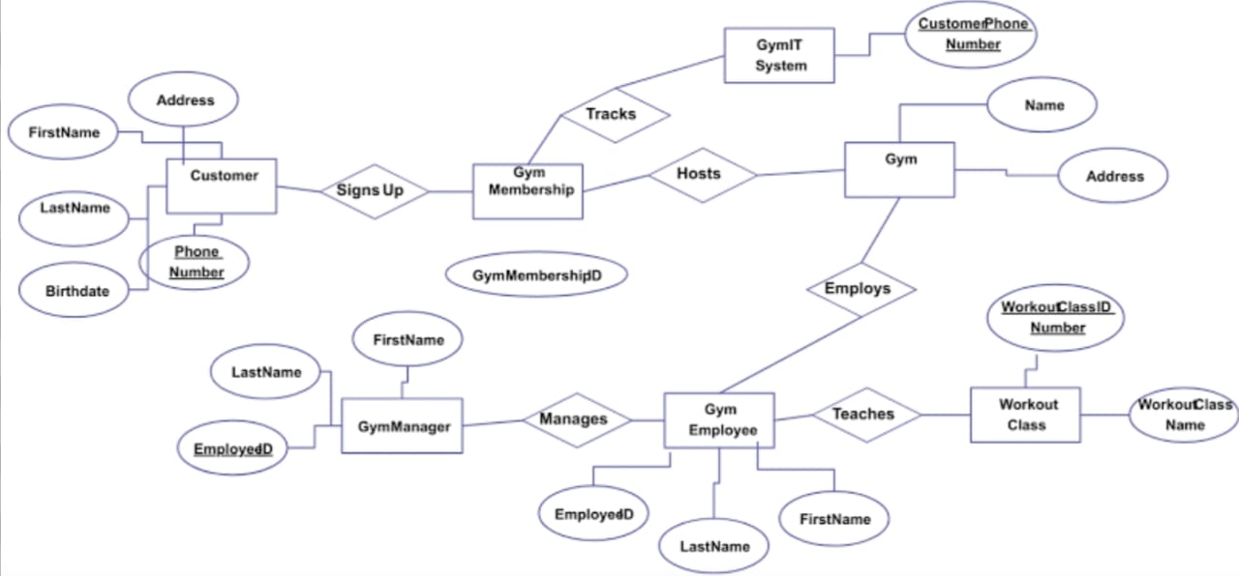

UI Design :

